

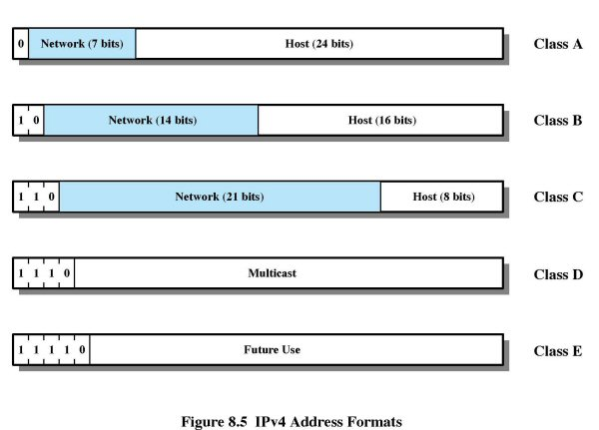TCP/IP Client Server Model

Port numbers below 1024 are reserved for system software:

|  |  |  |
| --- | --- | --- |
| telnet uses 23 | ftp uses 21 | email uses 25 |
| rlogin uses 513 | http uses 80 |  |

setSoTimeout(int timeout) -  allows a socket to wait for information (blocking for read) for only timeout milliseconds before raisingan *InterruptedIOException* exception

**Fixed Routing**: a single, permanent route is assigned to each source-destination pairs of nodes in the network Route change only when network topology changes.

**Adaptive Routing:** routing decisions change as network conditions change due to Failure, Congestion. **Drawback**: The more sophisticated the routing decisions, the greater the burden of processing on routers. **Advantages** of adaptive routing over fixed routing depending upon soundness of design and the nature of the load

**Autonomous System (AS):** a set of routers and networks managed by a single organization. Consists of routers exchanging information.

|  |  |
| --- | --- |
| Interior Routing Protocol **(IRP)** | Exterior Routing Protocol **(ERP)** |

Dijkstra's Algorithm

|  |  |
| --- | --- |
| * N = set of all nodes in the network * s = the source node * L(n) = cost of least-cost path from s to n currently known to the algorithm | * T=set of nodes so far considered   w(i,j)=link cost from node i to node j=   * + 0 if i=j   + > 0 if the two nodes are directly connected   + ∞ if the two nodes are not directly connected |

Algorithm: Repeat Steps 1, 2 and 3 until T=N

* Step 1: Initialize
  + T = {s}, start with the source node
  + L(n) = w(s,n), consider initial paths from source s to all its neighboring nodes n
* Step 2: Get next node
  + Find a node not in T that has the least-cost from node s and add it to T
  + Find xhttp://www.sju.edu/~bforoura/courses/lectures/stallings9/images/symbols/notin.gifT such that L(x) = min L(j) for all jhttp://www.sju.edu/~bforoura/courses/lectures/stallings9/images/symbols/notin.gifT
* Step 3: Update least-cost paths
  + L(n) = min [L(n), w(x,n) + L(x)] for all nhttp://www.sju.edu/~bforoura/courses/lectures/stallings9/images/symbols/notin.gifT

Bellman-Ford Algorithm

|  |  |
| --- | --- |
| * s = the source node * h = maximum number of links in a path at the current stage of the algorithm * Lh(n) = cost of least-cost path from s to n currently known to the algorithm | * w(i,j) = link cost from node i to node j =   + 0 if i=j   + > 0 if the two nodes are directly connected   + http://www.sju.edu/~bforoura/courses/lectures/stallings9/images/symbols/inf.gif if the two nodes are not directly connected |

Algorithm: Repeat Steps 1 and 2 until there is no change in the best path from s to n  
Step 1: Initialize

* + L0(n) = http://www.sju.edu/~bforoura/courses/lectures/stallings9/images/symbols/inf.gif
  + Lh(s) = 0 for all h
* Step 2: Update for successive h>=0
  + Lh+1(n) = min [Lh(j) + w(j,n)] for all j

Flooding

* Advantages of flooding:
  1. All possible paths between a source and destination are tried, so the packet is guaranteed to arrive at its destination as long as there is a path (highly robust)
  2. At least one copy of the packet will arrive using a minimum-delay route
  3. All nodes are visited (nodes' routing tables are always up to date)
* Shortcomings of flooding:
  1. It generates high traffic load
  2. The more connections among nodes, the higher the traffic

**IP (IPv4 or IPv6)** is a connection-less, or datagram, service between end systems. The header overhead in the IP protocil is a minimum of 20 octets

**Advantages** of connection-less approach:

|  |  |
| --- | --- |
| **Flexible**: It can deal with different types of networks, requiring very little from the constituent networks | **Highly robust**: Packets are routed independently  **Little overhead** for transport protocols |

**Fragmentation and Reassembly:**

**datagram fragmentation** technique uses the following information in the IP header

|  |  |
| --- | --- |
| **Data Unit Identifier (ID)**   * A sequence number that uniquely identifies an originated datagram * It consists of a source address (**SA**), a destination address (**DA**), and a protocol layer number that generated the data (TCP) and a protocol ID | **Data Length**   * Length of the user data field in bytes   **Offset**   * Position of the fragment of user data in the data field of the original datagram (in multiples of 8 bytes)   **More Flag**   * It indicates whether this is the last fragment or not |

**IP Addressing:**

**Dotted decimal notation**

* **11000000 11100100 00010001 00111001**is written as **192.228.17.57**
* **Class A**'s **0.x.x.x** and **127.x.x.x** are reserved addresses
* **Class B**'s range is from **128.x.x.x - 191.x.x.x**
* **Class C**'s range is from **192.x.x.x - 223.x.x.x**

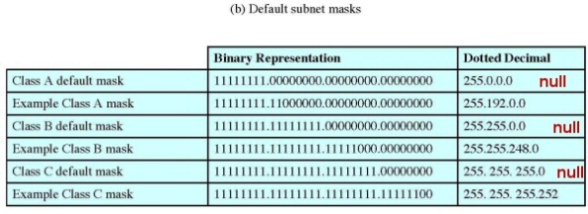

**Subnets and Subnet Masks**

* Default masks:  
  Class A: **255.0.0.0**
* Class B: **255.255.0.0**
* Class C: **255.255.255.0**

An example of **subnetting**

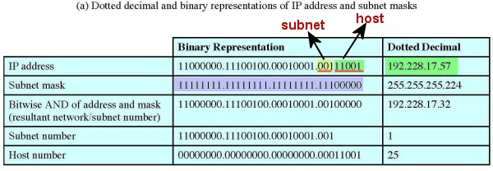

**Address Resolution Protocol (ARP)**

**DNS: Domain Name Servers:** 13 world-wide root name servers share responsibility for top level zones such as .com, .edu, .giv, .mil, .biz, .info, .net, .org, .name, .musuem, .int, etc.

* TCP/IP can use any of the 3 methods discussed
* The actual method chosen depends on underlying hardware
  + **Table lookups** are used in **WAN**s
  + **Closed-form** is used in **configurable networks (N/A)**
  + **Message passing** is used in **LAN**s with static addressing

ARP defines two operations:

* A **request:** An IP address
* A **response:** An IP address + a MAC address

Anatomy of an **ARP message**:

* 224 bits long (7 32-bit words)
* Hardware Address **Type is 1 when ARP is used with Ethernet**
* Protocol Address Type is **0x0800** when ARP is used with IP
* **Haddr Len** specifies length of hardware address
* **Paddr Len** specifies length of protocol address
* Operation: **1 for request** and **2 for response**
* Sender does not know the target's hardware address, so **Target Haddr** in an ARP request **can be filled with all 1's** since the contents are not used (a legacy field)

**18.6)** A 4480-octet datagram is to be transmitted and need to be fragmented because it will pass through an Ethernet with a maximum payload of 1500 octets. Show the Total Length, More Flag and Fragment Offset value in each of the resulting fragments.

**Ans**: The original datagram includes a 20-octet header and a data field of 4460 octets. The Ethernet frame can take a payload of 1500 octets, so each frame can carry an IP datagram with a 20-octet header and 1480 data octets. Note the 1480 is divisible by 8, so we can use the maximum size frame for each fragment except the last. To fit 4460 data octets into frames that carry 1480 data octets we need:

3 datagrams 1480 octets = 4440 octets, plus

1 datagram that carries 20 data octets (plus 20 IP header octets)

The relevant fields in each IP fragment:

|  |  |  |  |
| --- | --- | --- | --- |
| Total Length = 1500 | Total Length = 1500 | Total Length = 1500 | Total Length = 40 |
| More Flag = 1 | More Flag = 1 | More Flag = 1 | More Flag = 0 |
| Offset = 0 | Offset = 185 | Offset = 370 | Offset = 555 |

**18.10)** A transport layer message consisting of 1500 bits of data and 160 bits of header is sent to an internet layer, which appends another 160 bits of header. This is then transmitted through two networks, each of which uses a 24-bit packet header. The destination network has a maximum packet size of 800 bits. How many bits, including header, are delivered to the network-layer protocol at the destination?

**Ans**: Data plus transport header plus internet header equals (1500 + 160 +160) 1820 bits. We know that this data is delivered in a sequence of packets, each with 24 bits of network header and up to 776 (800 bits – 24-bit) bits of higher-layer headers and/or data. Three network packets are needed. Total bits delivered = 1820 + 3 × 24 = 1892 bits.

**18.13)** Provide the following parameter values for each of the network classes A, B, and C. Be sure to consider any special or reserved addresses in your calculations. Number of bits in network portion of address. Number of bits in host portion of address. Number of distinct network allowed. Number of distinct hosts per network allowed. Integer range of first octet

**Class A**: (a) 8 bits, (b) 24 bits, (c) first bit of the first octet in a class A address is 0

(leaving 7 bits), so $2^{7}$ = 128 – 2 (0 and 127 are disallowed) = 126 networks, (d) $2^{24}$ = 16,777,216 – 2 (host address cannot be all 0’s or all 1’s) = 16,777,214 hosts, (e) range: 1 through 126

**Class B**: (a) 16 bits, (b) 16 bits, (c) first two bits of the first octet in a class B address are 10 (leaving 14 bits), so $2^{14}$ = 16,384 networks, (d) $2^{24}$ = 65,536 – 2 (host address cannot be all 0’s or all 1’s) = 65,534 hosts, (e) range: 128 through 191

**Class C**: (a) 24 bits, (b) 8 bits, (c) first three bits in the first octet in a class C address are 110 (leaving 21 bits), so $2^{21}$ = 2,097,152 networks, (d) $2^{8}$ = 256 – 2 (host address cannot be all 0’s or all 1’s) = 254 hosts, (e) range: 192 through 223

**18.16)** Is the subnet mask 255.255.0.255 valid for a Class A address?

**Ans**: It is valid; it is called a noncontiguous subnet mask, because the 16 bits of the subnet mask are not contiguous. The RFCs, however, recommend against using noncontiguous subnet masks.

**18.17)** Given a network address of 192.168.100.0 and a subnet mask of 255.255.255.192, How many subnets are created? How many hosts are there per subnet?

Ans:255.255.255.192 = 255.255.255.11000000 = $2^{2}$ Subnet and $2^{6}$ host

**18.18)** Given a company with six individual departments and each department having ten computers or networked devices, what mask could be applied to the company network to provide the subnetting necessary to divide up the network equally?

**Ans:** 6 individual departments require at least 6 sub networks 255.255.255.11100000 = $2^{3}$ = 8 subnets 10 computers or network devices for each department require atleast 10 hosts so $2^{5}$ = 32. Or bother subnet and host can be $2^{4}$ = 16 so long as it is more then what is required for the company.

**18.19)** In contemporary routing and addressing, the notation commonly used is called classless interdomain routing or CIDR. With CIDR, the number of bits in the mask is indicated in the following fashion: 192.168.100.0/24. This corresponds to a mask of 255.255.255.0. If this example would provide for 256 host addresses on the network, how many addresses are provided with the following?

1. 192.168.100.0/23
2. 192.168.100.0/25

Ans:

1. Netmask: 255.255.254.0, shorthand: /23 [9-bit], number of addresses: 29 = 512
2. Netmask: 255.255.255.128, shorthand: /25 [7-bit], number of addresses: 27 = 128 = 126 hosts + 1 bcast + 1 net base